|  |  |  |  |
| --- | --- | --- | --- |
| **实验现象** | **Mask-target SOA**  **(含behavioral oscillation)** | **Prime-mask SOA** | **Prime duration** |
| **人类**  **数据** |  |  |  |
| **累加器**  **模型** |  |  |  |
| **SDMN**  **模型** |  |  |  |
| **OTEM**  **模型** |  |  |  |

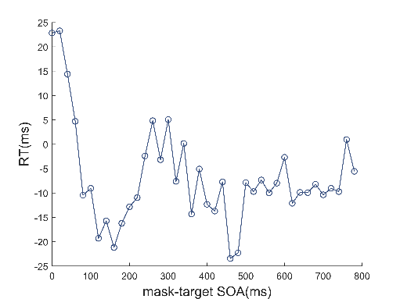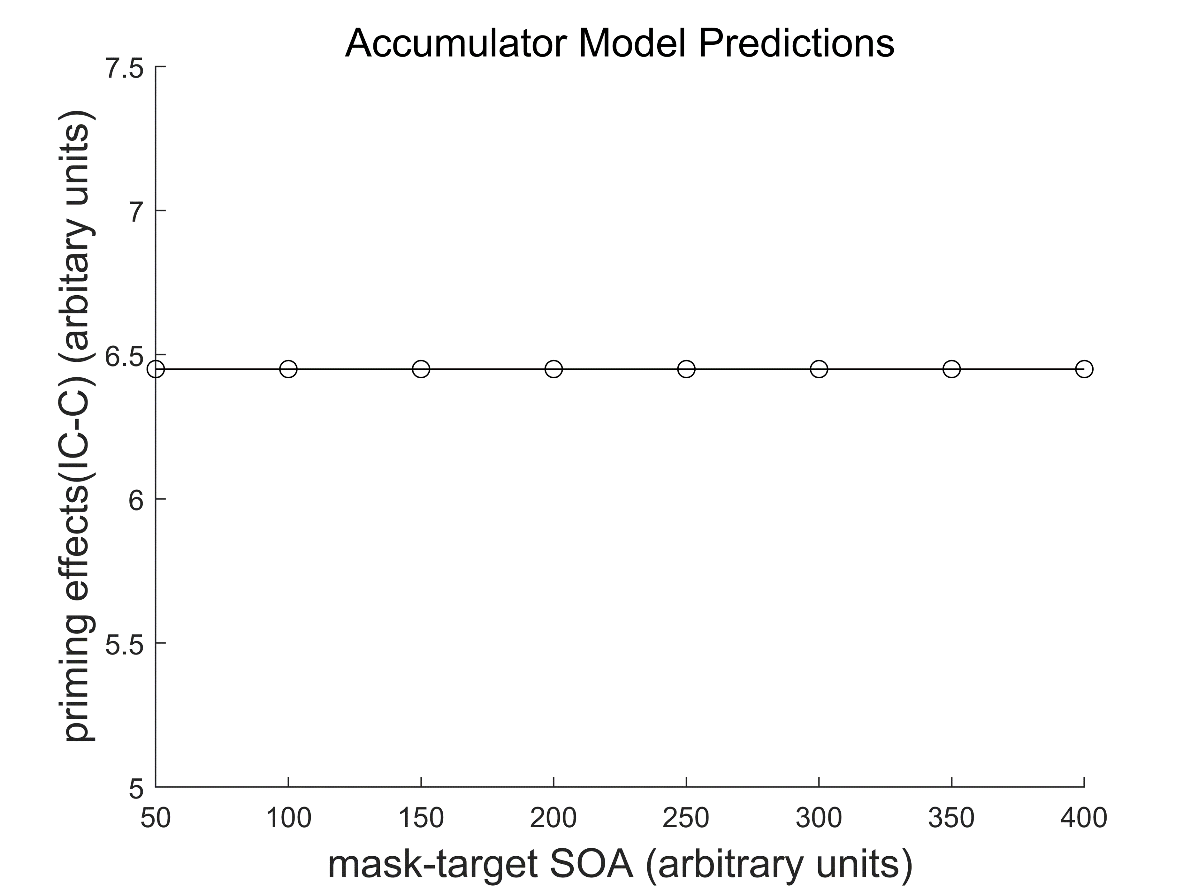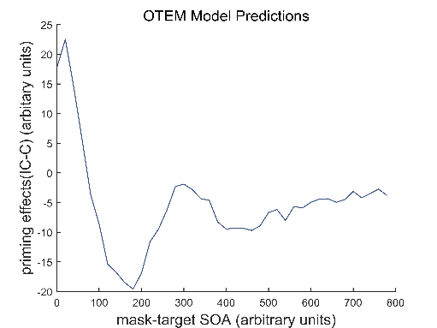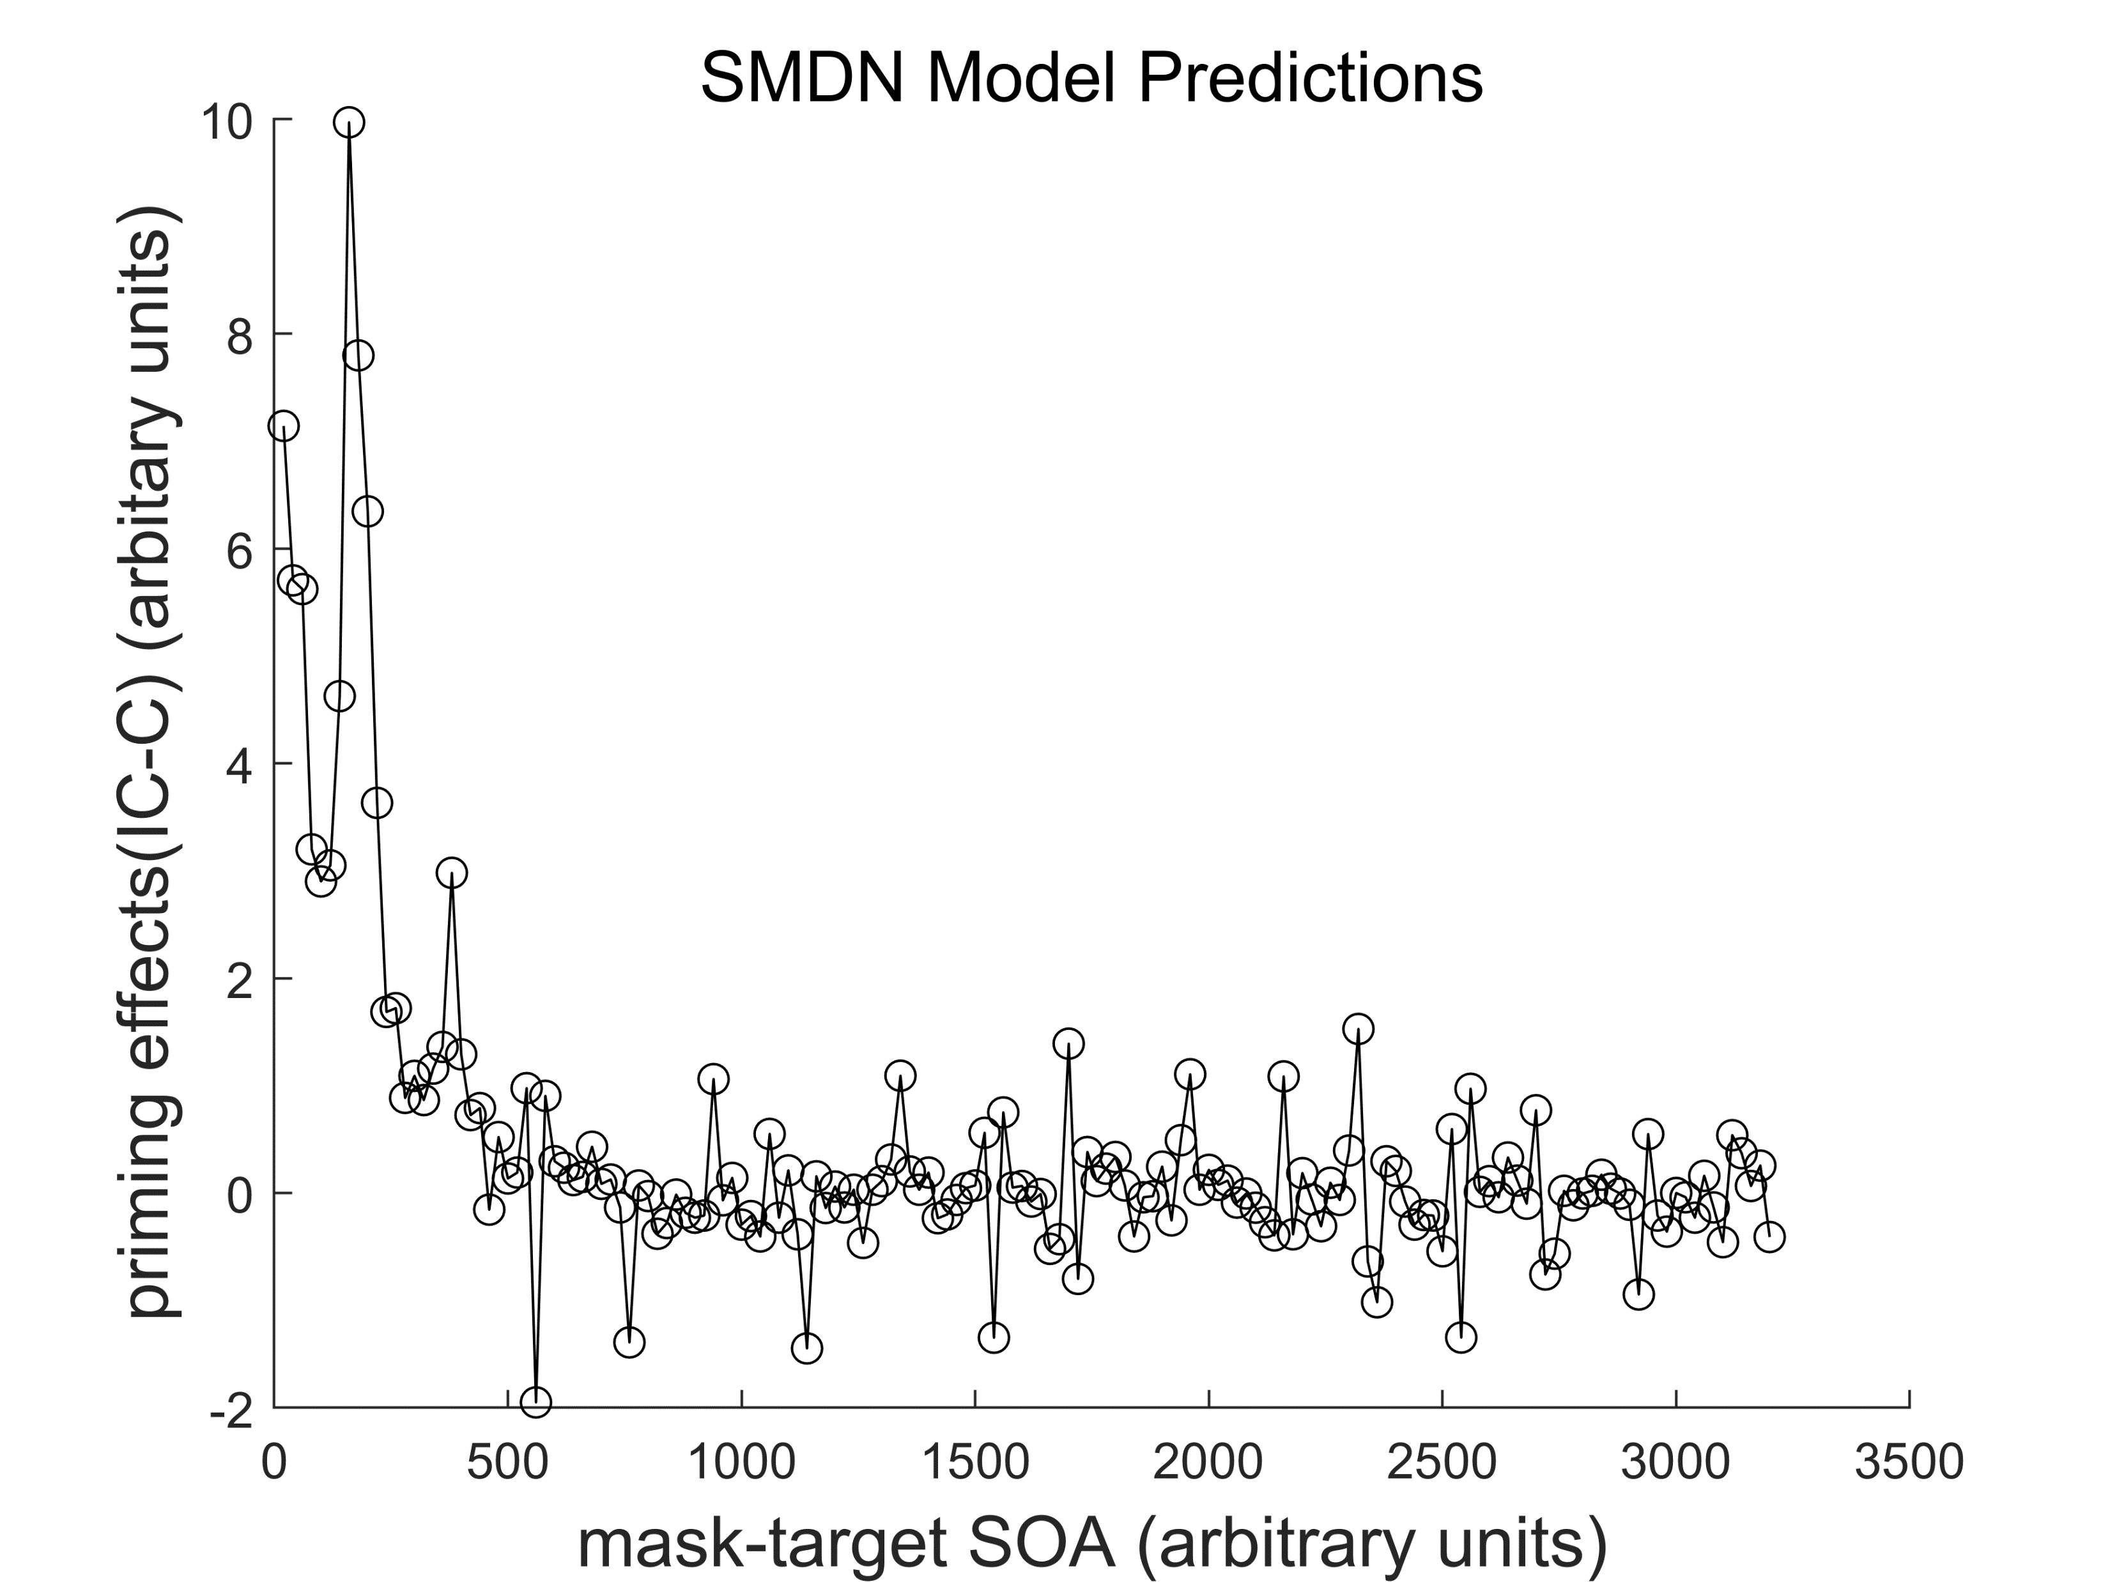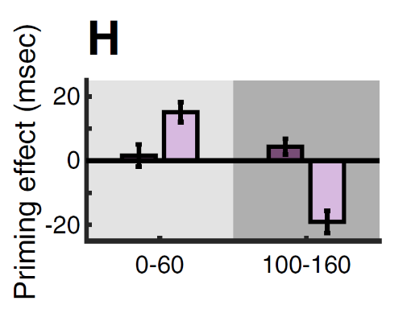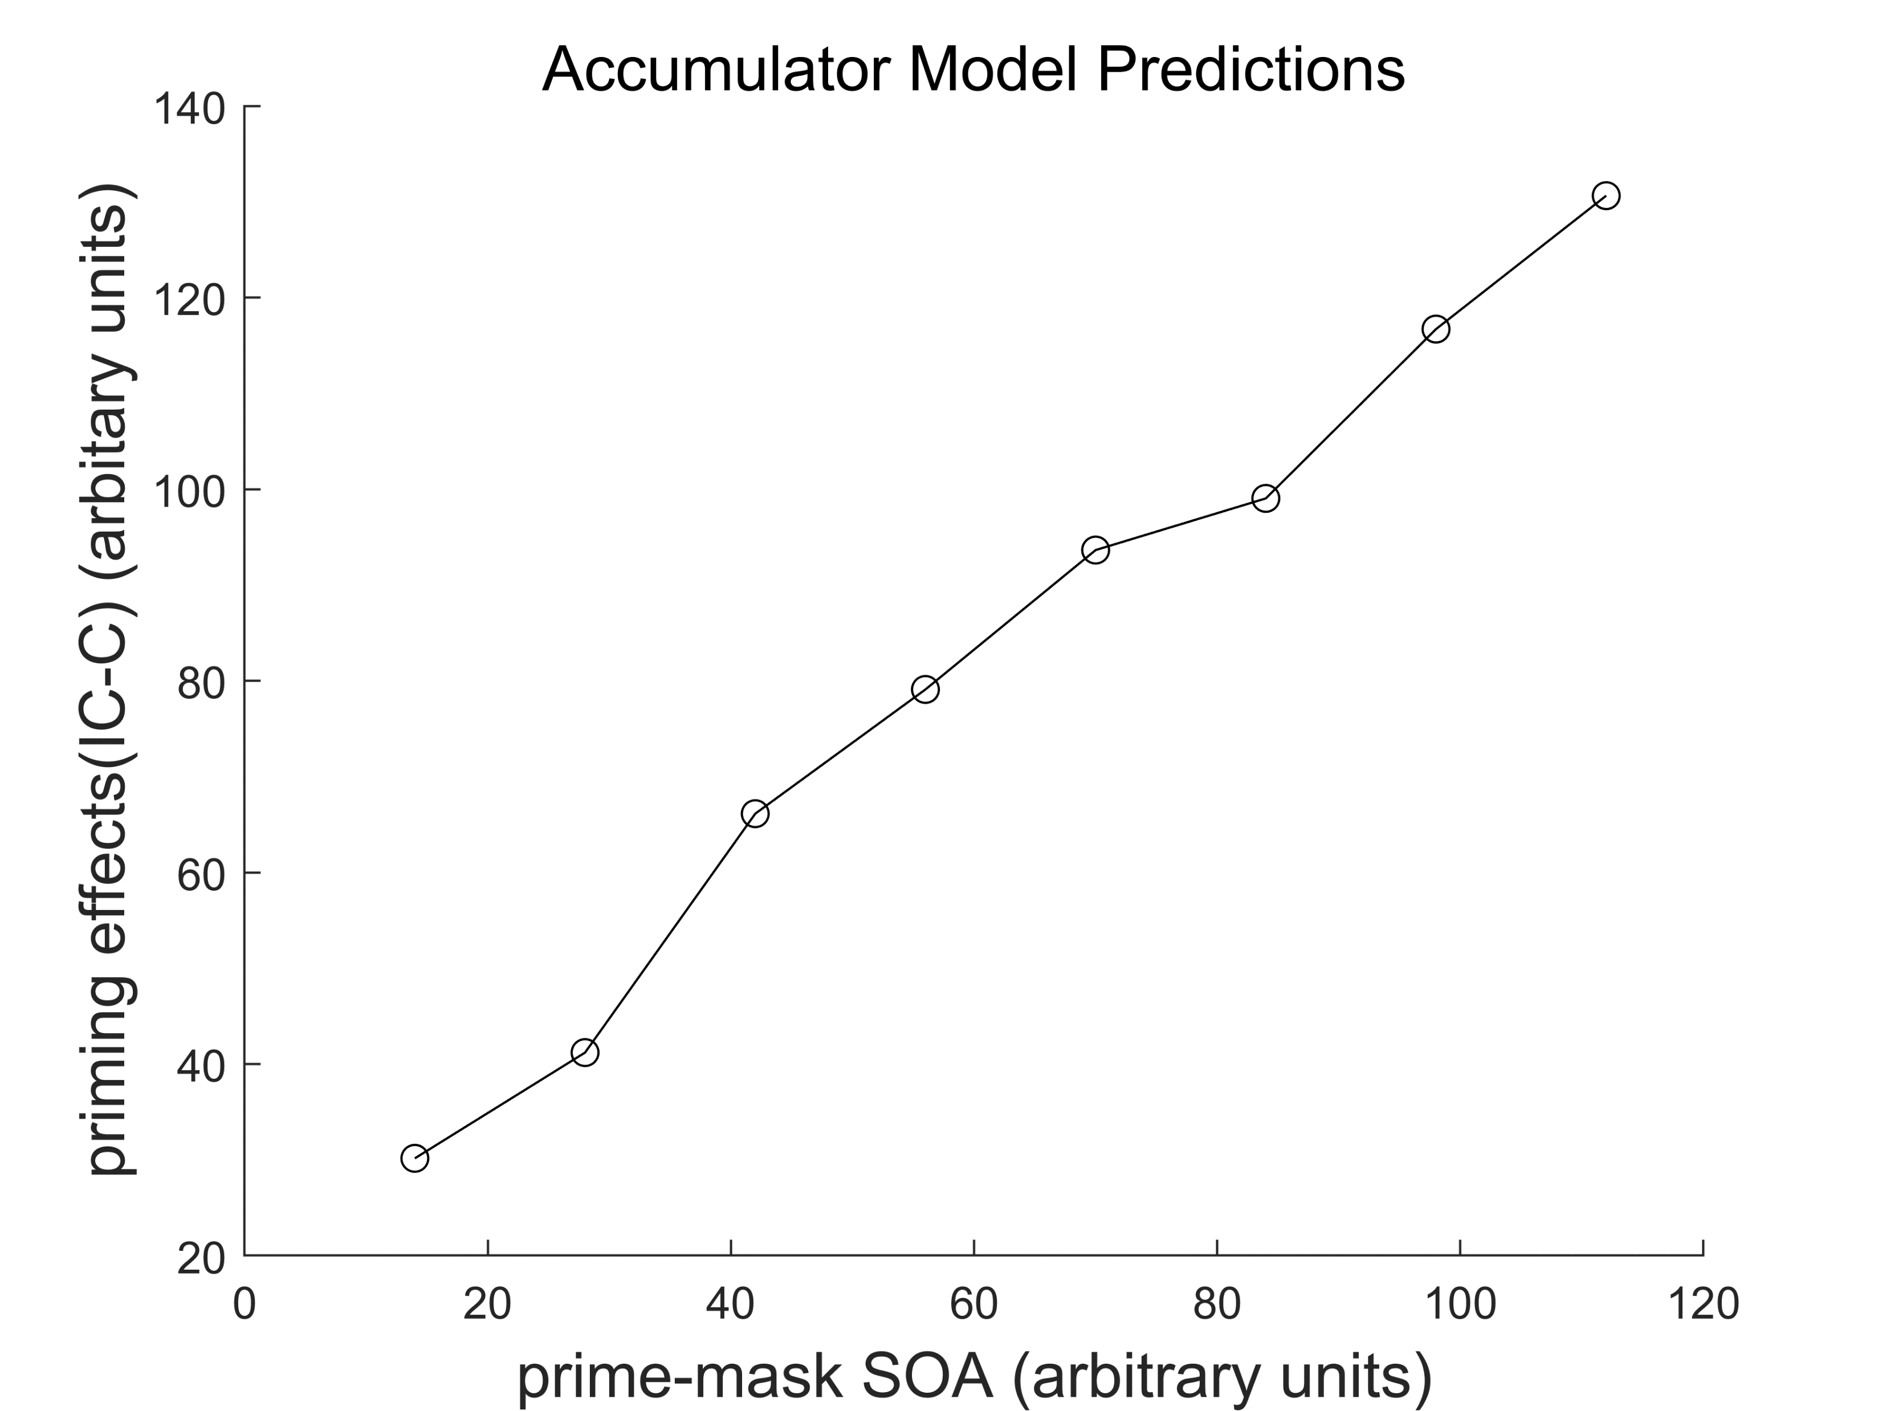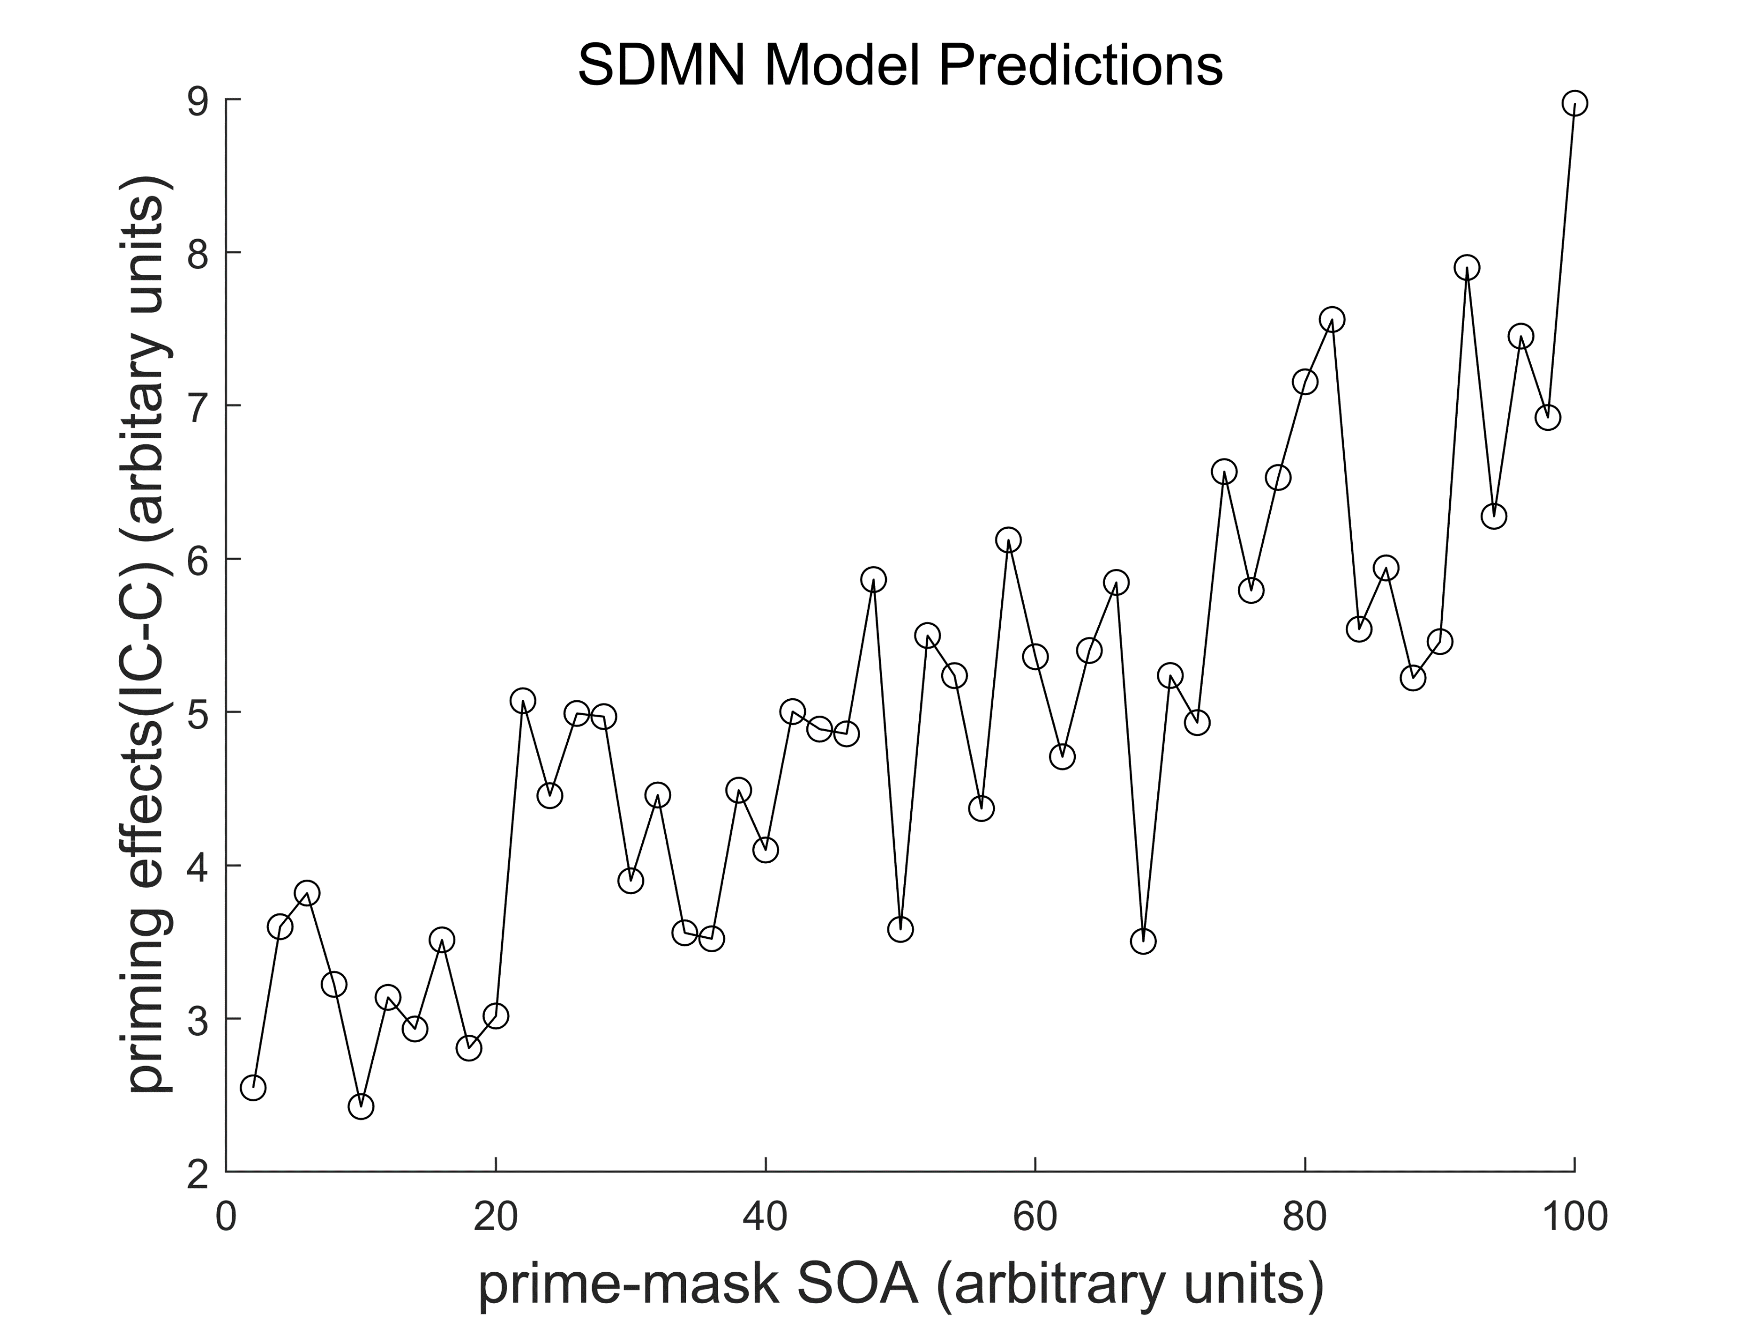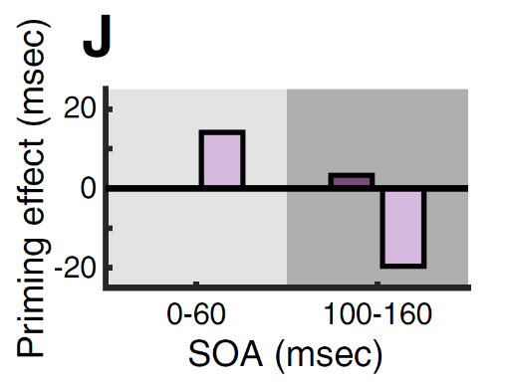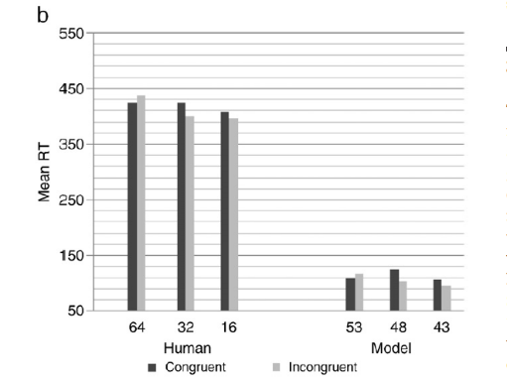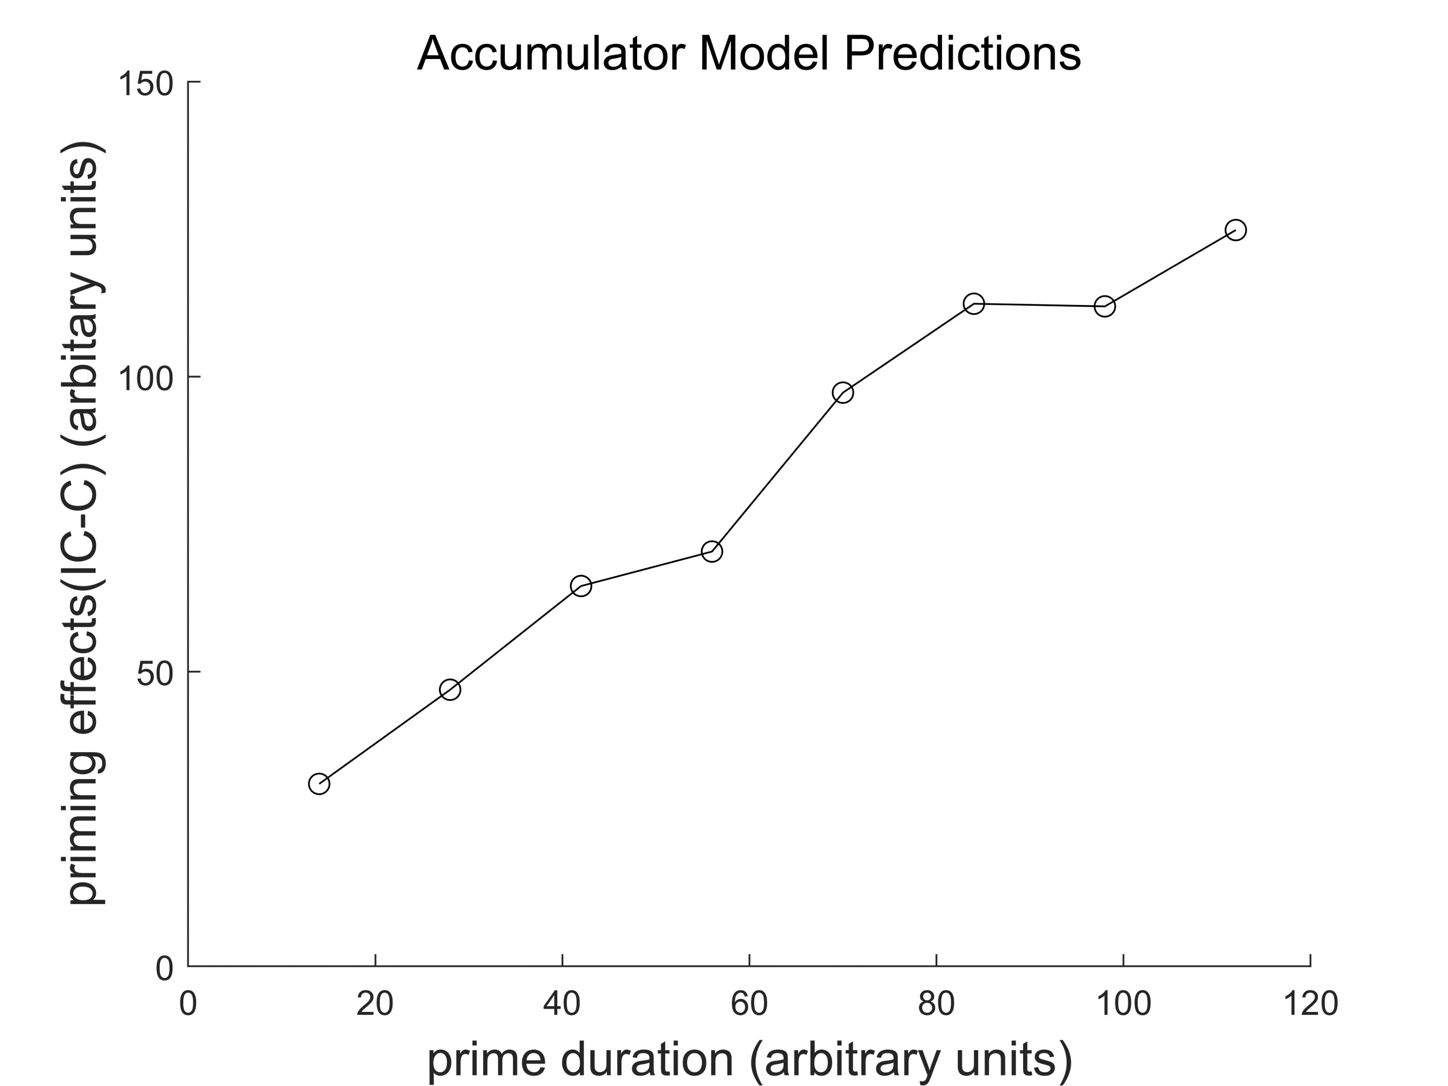

**ML**

**CL**

**RL**



**prime**

**mask**

**target**



**IL**

**AL**

**时间**

**时间**



**注视点**

**启动**

**刺激**

**目标**

**刺激**

**掩蔽**

Stimulus

Representation

Accumulator

λb

λ

-νnR

-νnL

nR-nL>c

=right

nL-nR>c

=left